ADVANCED SOFTWARE SERVICES, INC.
CAD-CAM USER MANUAL

Title Page

Table of Contents 1
Function Keys 2
Schedule Interface 3
Jobs 4
Materials 5
Machines 6
Sheet / Cad 7
Stack Information 8
Instructions 9
Schedule Options List 10
Reports 10
Scheduling Option Configurations 11
Browse Option 11
View Option 12

CAD-CAM
FUNCTION KEYS

The following describes the standard function keys:

BRWS = The browser is a list of records in the file. This is functionally equivalent
to the find option of our standard package.

VIEW = View records provides the ability to ADD, CHANGE, DELETE and UPDATE
an individual records.

SORT BY = The selections at the bottom of the browser which will sort the list in alphabetic order.

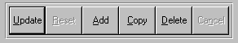

Update = Updating the current record.
Reset = Reset the current record.
Add = Add a record.
Copy = This will copy the existing record.
Delete = Delete the current record displayed on the screen.
Cancel = Canceling the information that was entered.
Save = Save the record.


 |  |  |  |  |  |  |  |  |  |  |  |  |  |  |  |  | First – Takes you to the first record
 |  |  |  |  |  |  |  |  |  |  |  |  |  |  |  |  | Prev – Takes you back one record at a time
 |  |  |  |  |  |  |  |  |  |  |  |  |  |  |  |  | Next – Moves forward one record
 | First |  |  |  | Prev |  |  | Next |  |  | Last |  |  |  |  |  | Last – Last current record
 |  |  |  |  |  |  |  |  |  |  |  |  |  |  |  |  | F2 – Search for a record
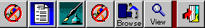 |  |  |  |  |  |  |  |  |  |  |  |  |  |  |  |  | F3 – List a record
 |  |  |  |  |  |  |  |  |  |  |  |  |  |  |  |  | F4 – Add notes to a record
 |  |  |  |  |  |  |  |  |  |  |  |  |  |  |  |  | F5 – Misc. fields
F2 |  | F3 | F4 |  |  | F5 |  |  | F6 |  |  | F7 |  |  | F12 |  | F6 – Brows the records
 |  |  |  |  |  |  |  |  |  |  |  |  |  |  |  |  | F7– View the records
 |  |  |  |  |  |  |  |  |  |  |  |  |  |  |  |  | F12 – Exit the screen

This effectively replaces the find feature of our legacy Foldware and Corrware products.
ADVANCED SOFTWARE SERVICES, INC.
CAD-CAM AND SCHEDULE INTERFACE (JOBS)
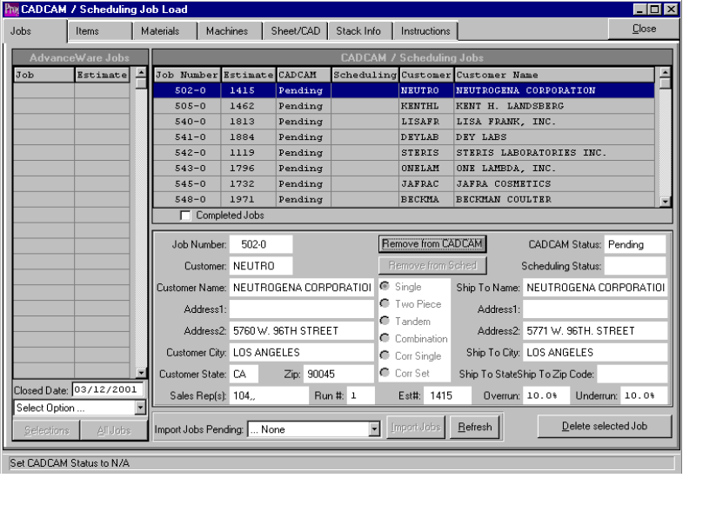

ADVANCED SOFTWARE SERVICES, INC.
CAD-CAM AND SCHEDULE INTERFACE (ITEMS)

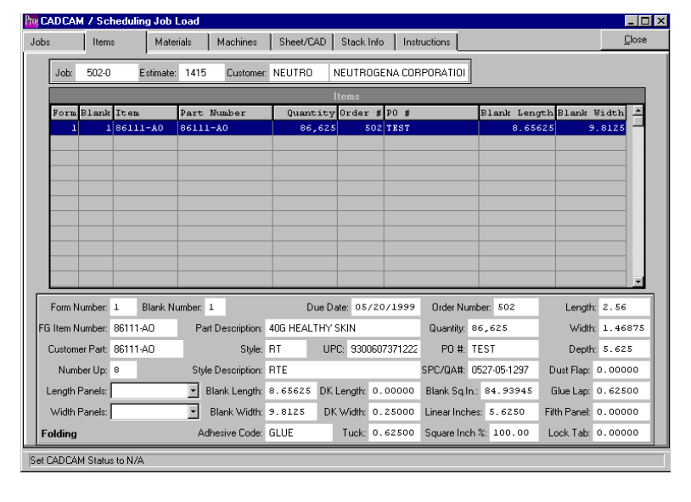

ADVANCED SOFTWARE SERVICES, INC.
CAD-CAM AND SCHEDULE INTERFACE (MATERIALS)

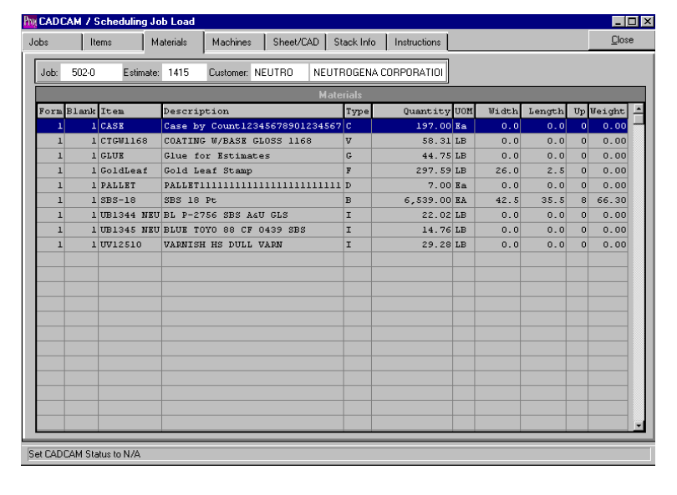

ADVANCED SOFTWARE SERVICES, INC.
CAD-CAM AND SCHEDULE INTERFACE (MACHINES)

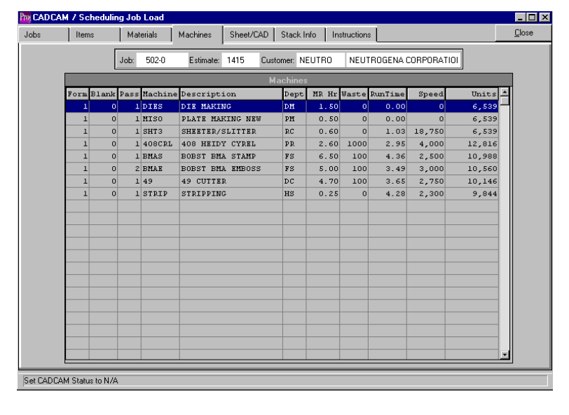

ADVANCED SOFTWARE SERVICES, INC.
CAD-CAM AND SCHEDULE INTERFACE (SHEET / CAD)

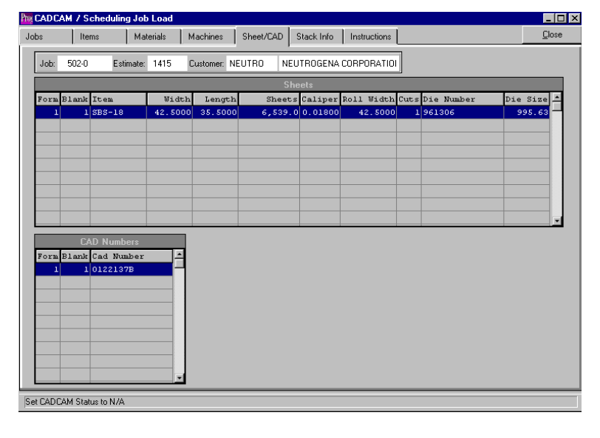

ADVANCED SOFTWARE SERVICES, INC.
CAD-CAM AND SCHEDULE INTERFACE (STACK INFORMATION)
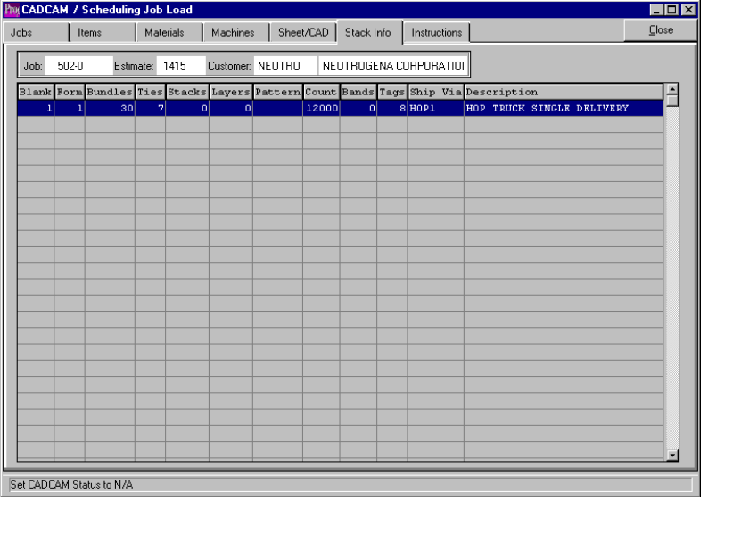

ADVANCED SOFTWARE SERVICES, INC.
CAD-CAM AND SCHEDULE INTERFACE (INSTRUCTIONS)
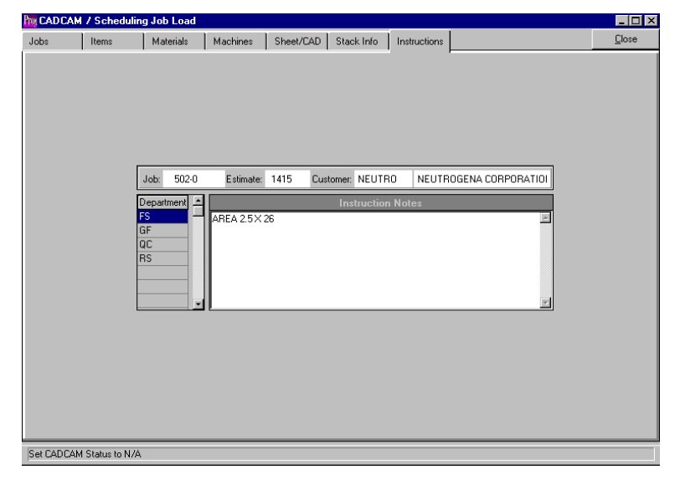

ADVANCED SOFTWARE SERVICES, INC.
CAD-CAM AND SCHEDULE OPTIONS LIST (REPORTS)
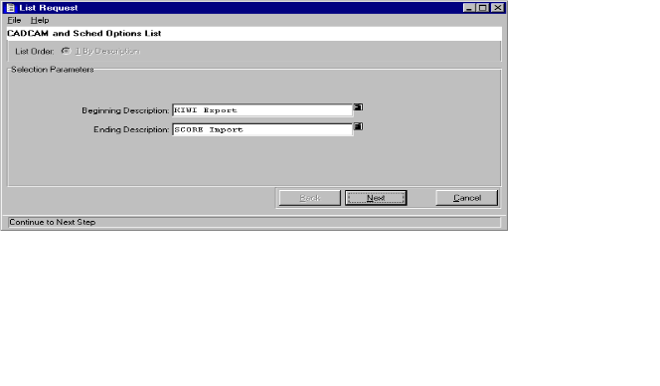

ADVANCED SOFTWARE SERVICES, INC.
CAD-CAM / SCHEDULING OPTION CONFIGURATIONS (BROWSE OPTION)
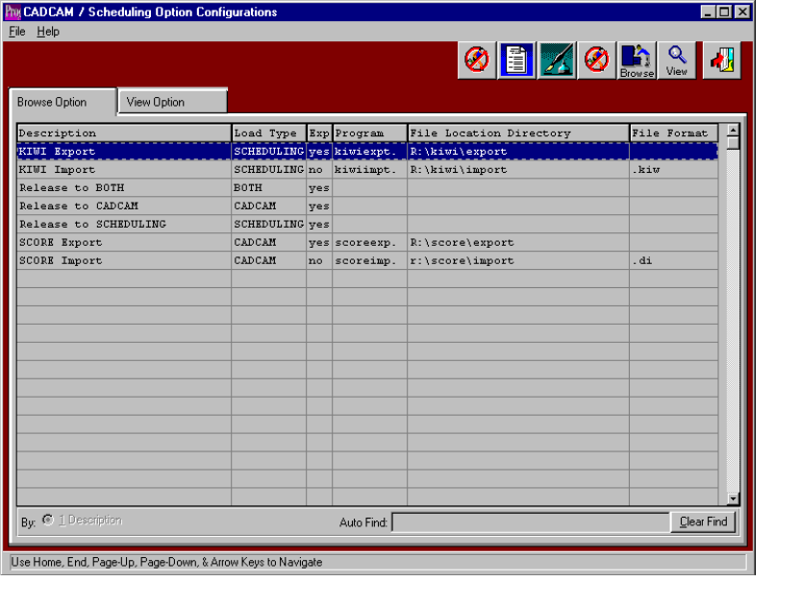

ADVANCED SOFTWARE SERVICES, INC.
CAD-CAM / SCHEDULING OPTION CONFIGURATIONS (VIEW OPTIONS)
